Glam media is huge! Or not...

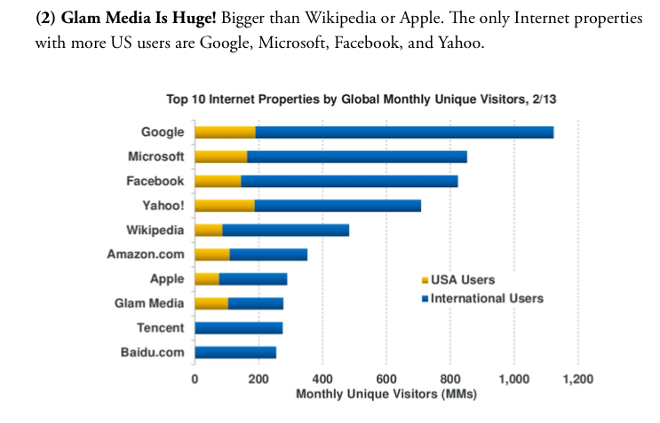

he source is [The Atlantic](https://www.theatlantic.com/politics/archive/2021/02/what-does-biden-want-from-the-impeachment-trial/618008/) magazine.

T​he intended audience is the social media users and maybe potential stakeholders.

The title of the visual is:

"**Glam Media Is Huge!**Bigger than Wikipedia or Apple. The only Internet properties with more US users are Google, Microsoft, Facebook, and Yahoo"

The bolded statement and its content directly provoces the attention of a social media users.

Q1. Misleading components of this visual are ​the stacked bar and the x-axis

Q​2 and Q3

* The stacked bars are a poor choice when it comes to comparrison , which is the case here. This is an example of using graphic forms in inappropriate ways (distorting the data).

The Glam media is not so obviously bigger than Wikkipedia or Apple. Infact the title doesn't immediately precise that the statement applies to US theritory only. The number of intetrational users is actually lower for Glam than for Wikkipedia or Apple (or it appears so). The stacked bar is useful when comparing totals so here can be very confusing for a reader as the total for the Glam is definitely bellow the total for Apple and especially for Wikipedia.

* t​he x-axis is misleading because of the unclear time interval. The y-axis presents only some social media .This would be an example of hiding relevant data to highlight what benefits us.

T​he x-axis only says that it represents a number of monthly unique visitors, but it is unclear for which month and/or time interval. The title actually implies that those data are only for month February 2013 (and the article was published in May 2013?!) which is definitely not a representative sample.

T​he author also doesn't provide the reason for the choice of social media for this comparison. Why exactly those 10? Do they have the biggest number of users?

It is very unclear which resources is the author using in his analysis. Also the text above the visual is purposely misleading the reader that The Glam is "huge" while there are no clear evidence for such a statement and the visual is actually telling us differently when we look at the international numbers. I believe that the author was here intentionally misleading the reader to create "bombastic" news with no evidence, poor visual and controversial conclusions that can be drawn from this visual .